**FIRST TERM E-LEARNING NOTE**

**SUBJECT: COMPUTER STUDIES CLASS: SS 3**

**SCHEME OF WORK**

**WEEK TOPIC**

1. **NETWORK**
   1. -Definition of networking.
   2. -Types of networking.
   3. -Network topology.
   4. -Network devices.
   5. -Benefits of networking
2. **INTRODUCTION FOR WORLD WIDE WEB** 
   1. -Definitions and full meaning of www
   2. -Brief history of www
   3. -Introduction to www
   4. -Basic terminologies protocols
   5. -Uses/benefits of www
   6. -Navigating through websites
   7. -Software for web development
3. **CABLES AND CONNECTORS**
   1. cables and connectors
   2. -Network cables and connectors
   3. -Computer cables and connectors
4. **DATA BASE**
   1. -Definition
   2. -Examples of DBMS
   3. -Basic technologies
   4. -Forms of data base organization
5. **DATABASE** 
   1. -Creating database
   2. -Basic operations
6. **GRAPHICS (INTRODUCTION TO COREL DRAW)**
   1. -Definition of graphics, examples of graphics
   2. -Features in CorelDraw e.g. environment: tools, color pallets.
7. **GRAPHICS (COREL DRAW)**
   1. -Simple design.
8. **BASIC PROGRAMING III**
   1. -Basic programming III (one-dimensional array)
   2. -DIM statement
   3. -Review of the for next statement, while end statement
   4. -Write BASIC program
   5. -Calculate the area of 10 different rectangles with and without while-end statements.
9. **HIGH LEVEL LANGUAGE**
   1. Definition of HLL.
   2. -Examples:- BASIC, FORTRAN, ALGOL etc.
   3. Classification of (HLLs)
   4. Features of BASIC, C, PASCAL, COBOL
   5. -Advantages of HLL over ML, LLL
10. **OVERVIEW OF NUMBER BASES**
    1. -Review of number bases: decimal, hexadecimal.
    2. -Conversion in number bases
    3. -Basic arithmetic in number bases
    4. -Addition and subtraction
11. **REVISION**
12. **EXAMINATION**

**REFERENCES:**

1. HiiT @ School, Computer Studies for Senior Secondary Education

2. MELROSE Computer Studies for SS 3 by O.B. Ajayi

**WEEK 1 DATE:.............................................**

**TOPIC: NETWORK**

**CONTENT:**

* **Definition of networking.**
* **-Types of networking.**
* **-Network topology.**
* **-Network devices.**
* **-Benefits of networking**

**NETWORKING**

A computer network often simply referred to as a network, is a collection of computers and devices interconnected by communications channels that facilitate communications among users and allows users to share resources.

A computer network allows sharing of RESOURECES and INFORMATION among interconnected devices.

Network exists for one major reason: to share information and resources.

**Types of Network**

Network can be grouped into three categories, namely;

A. By Scale

B. Topology

C. Functional Relationship

**Types of Network According to Scale**

Depending upon the geographical area covered by a network, it is classified as:

1. **Personal Area Network (PAN):** PAN is a computer network organized around an individual person (typically within 10 meters). PAN may be wired with computer such as USB and Fire wire. A wireless Personal Area Network (WPAN) can be made possible with network technology such as infrared Data Association (irDA) and Bluetooth.

2. **Local Area Network (LAN):**A local area network is a computer network covering a small local area, like a home, office, or school. The various technologies that are deployed on LAN are discussed below.

1. Ethernet: is a bus topology LAN network system. It uses coaxial or twisted pair cables to connect computer systems
2. Token ring: LAN technology is a ring topology network. It uses a special three-byte frame called token that travels around the ring. Physically, when implemented, the computers are connected through cables to a “HUB”. It is the hub that manages the network in a ring topology manner. E.g IBM token ring
3. Arcnet: is an acronym from (Attached Resource Computer Network) is a star LAN topology network. It was the first widely available networking system for microcomputers and became popular in the 1980s for office automation tasks. It was developed by Murpy at datapoint corporation in 1976.

3. **Metropolitan Area Network (MAN):** MANs are large computer network usually spanning a large campus.

4. **Wide Area Network (WAN):** WAN is a computer network covering a broad geographical area. Example of WAN is the Internet. The internet is a worldwide network of computers that share information.

**NETWORK TOPOLOGY**

In computer networking, topology refers to the layout of connected devices. There are two types of network topology, physical topology and logical topology.

The physical topology of a network refers to the layout of the cables and network devices; and logical topology refers to the method of communication of the network devices. Network topologies are categorized into the following basic types:

a. Star topology

1. Bus topology
2. Ring topology

**Star topology**

In a star topology network, the network devices are connected to a central point like a STAR.

The central point may be a hub, a switch or a router. All the individual network devices communicate with the central point. Thus once the hub fails, the whole network is grounded but if any other network devices fails, the network will still be operating without the failed device.

It requires more cables because cables are laid from all the network devices to the hub.

Data on a star network passes through the hub or switch before continuing to its destination. The hub or switch manages and controls all functions of the network. It also acts as a repeater for data flow. E.g ARCNET

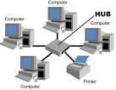

**Advantages of a star topology**

1. Easy to install and wire
2. No disruptions to the network when connecting or removing devices
3. Easy to detect faults and to remove parts

**Disadvantages of a star topology**

1. Requires more cable length than a linear topology.
2. if the hub or switch fails, nodes attached are disabled.
3. More expensive than linear bus topologies because of the cost of the hubs etc

**Bus Topology**

Bus Topology uses a common backbone(a cable) to connect all devices. The backbone is a shared communication medium that all devices are attached or connected.

A device wanting to communicate with another device on the network sends a broadcast message onto the wire that all other devices see, but only the intended recipient actually accepts and processes the message. It works with a limited number of devices but if the backbone cable fails, the entire network fails. Also, if any of the devices are down, the network fails. E.g Ethernet

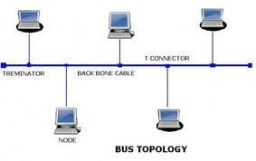

**Advantages of Bus Topology**

1. Easy to connect a computer or peripheral to a linear bus
2. Requires less cable length than a star topology

**Disadvantages of Bus Topology**

1.entire network shuts down if there is a break in the main cable

2. Terminators are required at both ends of the backbone cable 3. difficult to identify the problem if the entire network shuts down.

**Ring Topology**

In a ring network, all the network devices are connected together in a ring form. That is every device has exactly two neighbours for communication purposes.

All messages travel through a ring in the same direction. A failure in any cable or device breaks the loop and can shut down the entire network. E.g IBM token ring

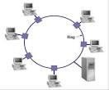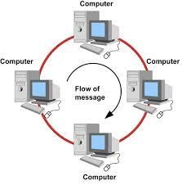

**NETWORK DEVICES**

The network devices are the nodes of the network. They are devices that aid connection and communication. The common network devices are:

The Hub, the network interface card, the switch, the router, the modem.

**1.The Hub**

A hub is a device that connects all the other devices in a star network together. Every device in the network connects directly to the hub through a single cable.

The hub receives a message from a device and broadcast it to all the other devices in the network and monitors it for collision to the destination.

Due to the fact that the hub broadcast messages, any message sent by the hub is received by all the devices because the hub is not able to identify the device that owns the message. This is the reason why, people say the hub is not intelligent.

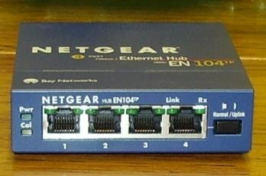

1. **Modems**

Modem is an acronym for modulator/demodulator; it is a device that can convert a digital data to an analog data and vice versa.

The most familiar example is a voice band modem that turns the digital data of a personal computer into modulated electrical signals in the voice frequency range of a telephone channel.

These signals can be transmitted over telephone lines and demodulated by another modem at the receiver side to recover the digital data.

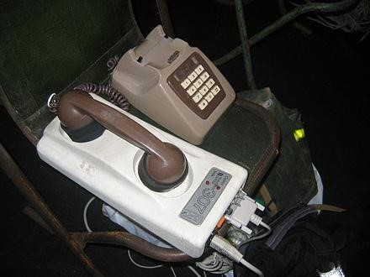

1. **Switches**

A switch is a device that channels incoming data from any of network device to the specific device that is the destination of the data.

Unlike the hub, the switch is intelligent because it does not broadcast but channels the data to the specific destination.

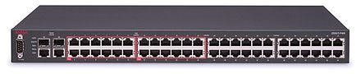

**4. Bridge**

A bridge is a device that connects two similar networks together. A bridge will connect/join two ring networks together or two star networks together. It could connect many similar networks together.

**5. Routers**

A router is network device that connects two or more dissimilar networks together. For example, a router can connect a ring network with a star network, a wireless network and a cable network, a LAN with a WAN and so on.

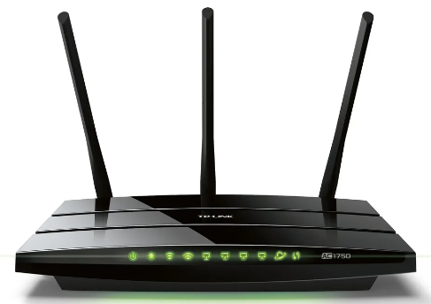

**6. a Network Interface Card (NIC)/ Network interface controller/network(LAN) adapter**

A network interface is a computer hardware component that connects a computer to a computer network.

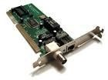 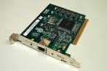

**Benefits of Computer Networking**

1. Helps to enhance connectivity
2. Networking helps in sharing of hardware resources
3. Eases out management of data
4. It gives room to connect people in different parts of the world.

5.It also help in data sharing where it facilitates the use of applications like databases that are based on ability of many individuals to access and share exactly the same data.

6. It promotes game where players all over the world using common servers play with one another.

**WEEK 2 DATE:.............................................**

**TOPIC: INTRODUCTION FOR WORLD WIDE WEB**

**CONTENT:**

* **-Definitions and full meaning of www**
* **-Brief history of www**
* **-Introduction to www**
* **-Basic terminologies protocols**
* **-Uses/benefits of www**
* **-Navigating through websites**
* **-Software for web development**

## Topic: Introduction To World Wide Web

World Wide Web is a system of interlinked hypertext documents accessed via the internet. The World Wide Web is a global information medium which users can read and write via computers connected to the internet. The term is often mistakenly used as a synonym for the internet itself but the web, is a service that operates over the internet, just as e-mail also does.

**Brief About World Wide Web (WWW)**

1979 – 1991 – Development of the World Wide Web

1992 – 1995 – Growth of the World Wide Web

1996 – 1998 – Commercialization of the World Wide Web

1999 – 2001 – Dot – com boom and bust

2002 – Present – The web becomes ubiquitous

## History of World Wide Web

The web was developed between march 1989 and December 1990 and Tim Berners – Lee refining it with input from the internet community of the era until 1993 using concepts form his earlier hypertext systems such as ENQUIRE, British Engineer Tim Berners – Lee, a computer scientist and at that time employee of the CERN, now Director of the World Wide Web. Web consortia (W3C) wrote a proposal in March 1989 for what would eventually become the world wide web.

The 1989 proposal was meant for more effective CERN communication system but Berners-Lee eventually realized the concept could be implemented throughout the world. At CERN, a European research organization near Geneva straddling the border between France and Switzerland.

Berners – Lee and Belgian computer scientist Robert Cailliau proposal in 1990 to use hypertext “to link and access information of various kinds as a web of nodes in which the user can browse at will and Berners – Lee finished the first website in December that year. Berners – Lee posted the project on the hypertext newsgroup on 7th August 1991.

## Basic Terminologies Of WWW

1. www – World Wide Web. It refers to all the web sites, resources and users in the internet that are using HTTP (Hyper Text Transfer Protocol). It is also a universe of network accessible information, an embodiment of human knowledge.

You can link from one document to another simply by clicking on **hot spot** e.g www.hotmail.co.uk, [www.google.com](http://www.google.com/) etc

1. Website is also written as website is a set of related web pages served from a single web domain.

The pages of a website can usually be accessed from a simple Uniform Resource Locator (URL).

1. Webpage is a document, typically written in plain text interspersed with formatting instructions of HTML. It is accessed and transported with the HTTP.

1. Homepage is refers to the initial or main web page of a website sometimes called the front page.

1. Protocols is a set of rules that governs the communication between computers in a network.

1. HTTP is the protocol to exchange or transfer hypertext, it governs exchange, transfer and distribution of html documents in the www. It is the foundation of data communication for the world wide web. Is the set of rules for transferring files e.g text, graphics images, sound, video and other multimedia files on the www.

1. HTML is a computer language devised to allow website creation. It is the predominant markup language for web pages.

1. Web browser is a software application that enable computers users to locate and access web pages.

Browser translates the basic HTML code that allows a user to see images text video and listen to audios on websites and connects to other web pages through hyper links e.g Mozilla Firefox, Microsoft Internet Explorer, Google chrome, Netscape Navigator etc.

**Uses/Benefits of World Wide Web**

1. Cheaper and flexible advertising
2. Supports E – learning
3. Market Expansion which boost the economic of the country
4. Promotes E – commerce
5. Offer convenience
6. Increase in sales and revenue earning
7. Growth opportunity
8. Improve credibility

**Software for web development**

1. Microsoft front page

It is a WYSIWYG HTML editor and web site administration tool from Microsoft (WYSIWYG means What You See Is What You Get)

1. Macromedia tools e.g freehand, flash, dream weaver, fire works
2. Adobe Tools e.g Adobe Tools e.g Adobe dream weaver, fireworks and flash
3. Others e.g web studio, coffee cup, Note pad etc.

**WEEK 3 DATE:.............................................**

**TOPIC: CABLES AND CONNECTORS**

**CONTENT:**

* **Cables and connectors**
* **-Network cables and connectors**
* **-Computer cables and connectors**

## Topic: Network Cables and connect cables

Network cable is used to connect and transfer data between computers and a network. There are different types of network cable, and the appropriate type to use will depend on the structure and topology of your network.

The most commonly used types of network cable are:

1. Twisted pair
2. Coaxial cable
3. Optical fiber cable
4. Telephone cables

1. Twisted pair cabling is the type of wring in which two conductors are twisted together for the purpose of cancelling out electromagnetic interference (EMI) from external sources. One were carries the signal, and another is used as a ground reference. The twisted pair cables are mainly used for Ethernet networks and telephone lines. Pair cables were invented by Alexander Graham Bell in 1881.There are two types of twisted pair cables (a) UTP (Unshielded Twisted Pair)

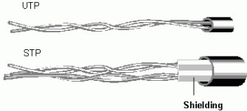

(b) STP (Shielded Twisted Pair): These have one extra metal shield covering the insulated twisted conductors, thus preventing electromagnetic interference.

1. Coaxial Cables: A coaxial cable or coax is an electrical cable with an inner conductor surrounded by a flexible tabular conducting layer, Surrounded by a tabular conducting shield. The term coaxial comes from the inner conductor and the outer shield sharing the same geometric axis. Coaxial cable was invented by English engineer and mathematician oliver Heaviside in1880. Coaxial cables carry high frequency signals than twisted pair cables.

**Uses of coaxial cable**

1. It is used for connecting TV antenna to TV sets.
2. It is used a transmission line for radio frequency signal.
3. It is used in Ethernet bus network

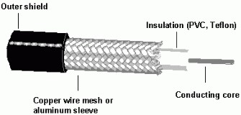

3. Fibre Optic: This technology uses glass (or plastic) threats (fibre) to transmit data. It is similar to copper wire cable, the difference is that fibre optics use light pulses to transmit information down fibre line instead of using electric pulses to transmit information.

**Advantages of fibre optic over copper cable/traditional metal comm. lines**

1. Speed : It operates at high speed, up to gigabites
2. Bandwidth: It has a much larger carrying capacity (carrying more data)
3. Distance: Signals can be transmitted much more further without needing strengthening or refreshing
4. Resistance: It has a greater resistance to electromagnetic noise. Such as radios, motors, or other nearby cables
5. Maintenance: It is cheaper to maintain fibre optic cables.

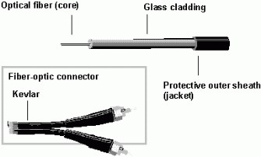

4. Telephone cable: It is a type of male connector used to connect a telephone to the telephone wiring in a home or business, and in turn to a local telephone network. It is inserted into its female counterpart, a telephone “jack” commonly fixed to a wall or base board. The standard for telephone plugs varies from country to country.

**Connector**

It is a part of a cable that plugs into a port or interface to connect one device to another. Connector is a device for joining electrical circuits together. Connectors are chosen in reference to the cable and device which are to be connected.

**Types of Connectors**

(a) RJ 45 (b) RJ 11 (c) T connector

RJ 45 is the short name for Registered jack 45. It is an eight wire connector used commonly to connect computers into a transmission.

**Computer cables and connectors**

1. Power cable: a power cable is an assembly of two or more electrical conductors, usually held together with and overall sheath. The assembly is used for transmission of electrical powers. These are used to supply electricity into the computer systems.
2. Data cables: Is a transmission medium required to carry information form a source to a destination. The information is usually a signal that has to travel a long distance. The transmission media could be wired or wireless. In wired transmission, the signal travels along the cable from one device to another. These devices of data transmission are called data cables e.g printer cable, USB cable, monitor cable.

**Printer cable**: refers to the cable that carries data between a computer and a printer. e.g Serial cables, Parallel cables, USB cable, Fire cable

**Monitor cable**

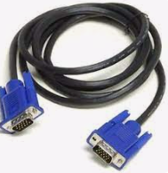

A monitor cable or a VGA (Video Graphics Array) cable is a cable used to transmit video signals

**Serial cable**

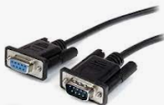

A serial cable is a cable used to transfer information between two devices using a serial communication protocol.

**Universal Serial Bus Cable**



This cable is used for connecting peripheral devices to a computer.

**Types of Connectors**

1. **Male Connectors:** It always have a pin that can plug into a female socket or connector at the end of a cable.
2. **Female connector:** Sometimes called “socket” or “Jack” receive male connector.

**WEEK 4 DATE:.............................................**

**TOPIC: DATABASE**

**CONTENT:**

* **-Definition**
* **-Examples of DBMS**
* **-Basic technologies**
* **-Forms of data base organization**

## Topic: Database

A database is an organized collection of data. The data are typically organized to model relevant aspects of reality in a way that supports processes requiring this information. For example, modeling the availability of rooms in hotels in a way that supports finding a hotel with vacancies.

Database Management Systems (DBMS) are specially designed applications that interact with the user, other applications and the database itself to capture and analyze data.

A general purpose database management system (DBMS) is a software system designed to allow the definition, creation, querying, update and administration of databases.

**Examples of DBMS**

1. MySQL
2. Postgre SQL
3. Fox base
4. Sybase
5. Dbase IV
6. Oracle
7. Microsoft Access

**Basic Terminologies**

* + 1. Field: A field is a single piece of information.

1. Record: A record is one complete set of fields e.g

|  |  |  |  |
| --- | --- | --- | --- |
| File No | Name | Address | Contact No |
| 9164 | Ndi Chris | No32, Rope street, life camp | 08052469348 |

3. File: A file is a collection of records. e.g student file

|  |  |  |  |
| --- | --- | --- | --- |
| File No | Name | Address | Contact No |
| 9164 | Ndi Chris | No32, Rope street, life camp | 08052469348 |
| 9165 | Uche Rita | No 54, Ahmad street, Gwaripa | 08172345610 |
| 9166 | Usman Ali | Plot 10, life camp | 07034693461 |
| 9167 | Ajayi Tope | Plot 46, Gwarinpa | 08055439312 |

4. Key: A key is an attribute or field that can be used to identify a record in a database table or file.

**Forms of Database Organization (Database Models)**

A database model is the fundamental specification describing how a database is structured and use; that is how the data is stored organized, related and manipulated. It defines the set of operations that can be performed on the data.

There are many database models but the three basic database models are:

1. Hierarchical database model
2. Network database model
3. Relational database model

## Hierarchical Database Model

In a hierarchical model, data is organized into an upside – down tree – like structure, implying a single upward link in each record to describe the nesting, and a sort field to keep the records in a particular order in each same – level list.

It was widely used in the early mainframe database management systems e.g Information Management System (IMS) by IBM, also COBOL implemented the hierarchical database model.

It allows one – to – many relationship between two types of data. This structure is very efficient to describe many relationships in the real world like mother – child relationship: child may only have one mother but a mother can have multiple children.

Mothers and children are tied together by links called “pointers”. A mother will have a list of pointers to each of her children.

**Hierarchical database**

Fruit

Orang

Lime

Grape

Pear

Avocad

Sour

Sop

Berry

Rasp

berry

Cran

berry

## Network Model

The network model organizes data using two fundamental constructs, called records and sets. Records contain fields (which may be organized hierarchically, as done in COBOL). Sets define one – to – many relationship between records: one owner, many members. A record may be an owner in any number of sets, and a member in any number of sets. Thus the relationship between records and sets in many – to – many.

## Relational Model

This was introduced by Codd in 1970 as a way to make database management systems more independent of any particular application. A relational database uses tables with rows and columns to show relationships amongst data in a database. Relational database is very useful in creating multiple tables linked together using relationship Three key terms are used extensively in relational database models: relations, attributes and domains. A relation is a table with columns and rows. The named columns of the relation are called attributes and the domain is the set of values the attributes are allowed to take.

**Network model**

**Network database**

Preventive maintenance

Rigid Pavement

Flexible

Pavement

Spall Repair

Bint seat

Crack seat

Patching

Silicone Sealant

Asphalt Sealant

## Computer Database Format

Example of common Database Package is Microsoft Access. It is a relational database management system used to create and modify databases.

To create a database on the computer with MS Access: Load Microsoft Access by following these steps:

* Click on start menu
* Point to all programs
* Point to Microsoft Office
* Click on Microsoft Office Access

Ms Access start up windows is displayed.

**How To Create Database**

* From the displayed window, click on BLANK database
* By the right hand side of the windows click inside the file name text box and type the desired name

**To Create A File As Tables In Ms – Access**

* Click on create menu
* Select Table
* At Table tab, right click on any of the table
* Select Design View

This is where field and domain can be form.

Note: A table should contain a unique identifier i.e a key. The symbol of a key should appear beside the field

**WEEK 5 DATE:.............................................**

**TOPIC: DATABASE**

**CONTENT:**

* **-Definition**
* **-Examples of DBMS**
* **-Basic technologies**
* **-Forms of data base organization**

## Creating Database

In any Database Management System creating a database entails the following steps:

1. Define The Database Structure:

The database structure specifies the type of database organization that should be used. In a relational form, the database structure will includes structure if tables, number of rows, number of columns, the key and relationships of the database etc.

1. Specify Field Type:

When a database is being created, all fields are set to accept a particular type of input by specifying a field type. A field type is also known as a data type. The essence of a data type is to prevent a wrong input from being stored in a database. e.g Alpha numeric/text fields e.g Ola 20 Numeric field e.g 57, 3.22

Date field e.g 12/03/2011

Boolean field e.g Yes/No or True/False

1. Input Data

After the field names and their data types have been specified, the records are stored in the database by specifying the appropriate input.

* + Double click on the file name at the left hand pane of Ms Access window
  + Enter the data beneath the field names and click on the next cell to populate data. To keep database updated, data inputted into the database must be saved regularly.

## Basic Operations

The basic operations to be considered are:

1. Searching
2. Sorting
3. Modifying
4. Generating reports

**Searching**

1. On the Tools Menu, Click OPTION
2. Click the Edit/Find tab
3. Under Default Find/Replace behaviour

## do one of the following

Select FAST SEARCH to search the current field and match the whole field.

OR

Select GENERAL SEARCH to search all fields and match any part of the field.

OR

Select START OF FIELD SEARCH to search the current field and match the beginning characters of the field DBMS have certain commands for saving a database. For example in Ms Access select the save option on the Ms Access window to save.

**Sorting** Sorting Records in Form Viewer in Database View Follow these steps:

1. Start Microsoft Access and then open the database that you are working with
2. Open the table or the form whose data you want to view
3. Click the field that you want to use for sorting records. To sort records in a sub – datasheet, display the sub – database by clicking its expand indicator, and then click the field that you want to sort.
4. On the Records menu, point to sort and then click sort Ascending or sort Descending.

**NOTE**: In a form, you can only sort on only one field at a time

Modifying Data

How to Add or Edit Data in a Datasheet (Table or Query) or in a Form.

1. Open a table or a query in Datasheet view or a form in form view
2. In Microsoft Office Access 2007, to add a New record, click the HOME tab, and then click NEW in the Records group
   * To EDIT data within a field, click in the field that you want to edit, and then type the data
   * To replace the entire value, move the mouse pointer to the leftmost part of the field until the pointer changes into the plus pointer, and then click Type the data

**NOTE**: To correct a typing mistake press BACKSPACE or ESC to cancel How To Save A Record in a Datasheet or in a Form.

Microsoft Access automatically saves the record that you are adding or editing as soon as you move the insertion point to a different record or close the form or table that you are working on.

**How To Delete a Record in a Datasheet or in a Form**

1. Open a table or a query in Datasheet view or open a form you want to delete
2. Click the record you want to delete

In Access 2007, click HOME tab, and then click DELETE RECORD in the Delete list in the Records group.

**Generating Reports**

1. Auto Report
   * Open the database window (F11) and click on the Report tab
   * Click New. A dialog box appear
   * Select the table or query that you want to use for your report  Click OK
2. Create your own report
   * Repeat the first two steps above
   * When the dialog box appears, click design view
   * Select the table or query that you intend to use
   * Click OK
3. Report Wizard
   * Repeat the first two steps above
   * Click the wizard that you want to use for your report
   * Select the table or query that you want to use for your report
   * Click OK
   * Follow the instructions that the wizard provides

**WEEK 6 & 7 DATE:.............................................**

**TOPIC: GRAPHICS (INTRODUCTION TO COREL DRAW)**

**CONTENT:**

* **Definition of Graphics**
* **Examples of Graphic Packages**
* **Simple designs**

## Topic: Graphics (Introduction to Corel draw)

Computer Graphics are graphics created using computers and more generally, the representation and manipulation of image/pictorial data by a computer.

**Examples of Graphics Packages**

Common examples of graphic packages are:

1. Paint
2. Corel draw
3. Havard graphics
4. Adobe Photoshop
5. Ventura
6. Adobe page maker

**Features of CorelDraw Environment**

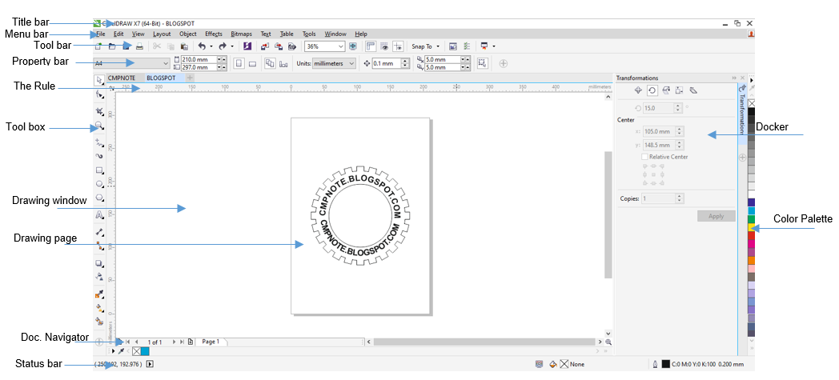

**1. Title Bar:** It is the first bar on the screen of any opened application. It gives information about the program which you are working on and also the name used in saving the document.  
**2. Menu bar:** Menu bar is the area containing pull-down menu options. CorelDRAW as a program has Eleven (11) menus, they include, File, Edit, View, Layout, Arrange, Effect, Bitmap, Texts, Tools Window and Help menu. Each menu has its function. When clicked on, the sub-menu list appears  
**3. Toolbar:**A detachable bar that contains shortcuts to the menu and other commands  
**4. Property Bar:**A detachable bar with commands that relate to the active tool or object. For example, when the text tool is active, the text property bar displays commands that create and edit text.  
**5. The Rule:** The rule (horizontal and vertical rule) enables us to determine the size and position of objects in a drawing.  
**6. Drawing page:** The area inside the drawing window. It is the printable area of your work area. Any work done outside of the printable page will not be printed  
**7. Drawing window:** The area outside the drawing page bordered by the scroll bars and application controls.  
**8. Colour Palette:** a dockable that contains colour swatches.  
**9. Docker:**A window containing available commands to settings relevant to a specific tool or task  
**10. Toolbox:** A floating bar with tools for creating, filling and modifying objects in the drawing  
**11. Status bar:** An area at the bottom of the application window that contains information about object properties. The status bar also shows the current mouse position.  
**12. Document Navigator:** The area at the bottom of the application window that contains controls for moving between pages and adding pages.

**Opening Corel draw from programs**

To access the Corel draw application take the following steps:

1. Click on the start button
2. Point to all programs
3. Point to Corel draw graphic suite 12
4. Select Corel draw 12

**WEEK 8 DATE:.............................................**

**TOPIC: BASIC PROGRAMING III**

**CONTENT:**

* **Basic programming III (one-dimensional array)**
* **-DIM statement**
* **-Review of the for next statement, while end statement**
* **-Write BASIC program**
* **-Calculate the area of 10 different rectangles with and without while-end statements.**

Topic: **Basic Programming III (one dimensional array i.e using DIM statement)** Basic programming language is a High level programming language.

An array is a list of variables of the same datatype. Arrays are useful for organizing multiple variables

To create and array, use the DIM (dimension) command

## Example of code without an array

10 A = 5

20 B = 10

30 C = 13

40 Print A, B, C

50 END

## Example of code with an array

10 DIM nos (2) 20 Nos(1) = 5

30 Nos(7) = 10

40 Nos(3) = 15

50 Print nos (1), nos (2), nos (3)

## List Of Operation On Array

Arrays can be manipulated in the following ways:

1. Input of an array

This example illustrates how to store values in an array

10 DIM ages (4)

20 Ages (1) = 12

30 Ages (2) = 10

40 Ages (3) = 13

50 Ages (4) = 15

1. Output of an Array

This example illustrates how to output values stored in an array

10 DIM ages (4)

20 ages (1) = 12

30 ages (2) = 10

40 ages (3) = 13

50 ages (4) 15

60 PRINT ages (1) ages (2) ages (3) ages (4)

1. Arithmetic on Array

This example illustrate how to perform arithmetic operation with values stored in array. 10 DIM ages (4)

20 ages (1) = 12

30 ages (2) = 10

40 ages (3) = 13

50 ages (4) = 15

60 Total = ages (1) + ages (2) + ages (3) + ages (4) 70 Average = Total / 4

80 Print “The Average of the value in the array is”, Average

## Basic programming III (one dimensional array)

1. Review of the loop instructions

1. For - - - To - - - Next statement

The FOR - - - To - - - NEXT statement is a loop statement used to repeat certain portion of a program a number of times.

* 1. CLS

20 DIM classes (4)

30 classes (1) = 20

40 classes (2) = 36

50 classes (3) = 24

60 classes (4) = 18

70 FOR X = 1 to 4

80 PRINT “Number in class” ; x ; “is”; classes (x);

90 NEXT X

100 END

1. Whle - - - End statement

The WHILE - - - END commands is used in a loop until a specified expression is false. To use WHILE - - - END

1. Place an expression after WHILE 2. Enter a list of commands

3. Place END at the end.

**Example:** write a program to print the first 10 even numbers using While - - End statement.

* 1. CLS

20 DIM Even number integer (10)

30 i = 1, n = 2

40 While I < = 10

50 PRINT “Enter even number” 60 INPUT “Even number” ; n

70 i = i + 1

80 Print “even numbers” ; n 90 End.

1. DIM statement

The DIM statement can be used to create variables including array variables.

* 1. DIM A as INTEGER

20 DIM Array (5)

30 END

**Examples Using Arrays**

1. Store data in a vector of 10 integer with and without a FOR NEXT statement

## Examples without FOR NEXT

10 CLS

20 DIM array (10)

30 array (1) = 5

40 array (2) = 10

50 array (3) = 15

60 array (4) = 20

70 array (5) = 25

80 array (6) = 30

90 array (7) = 35

100 array (8) = 40

110 array (9) = 45

120 array (10) = 50

130 END

## Example with FOR NEXT

10 CLS

20 DIM array (10)

30 FOR I = 1 to 10

40 array (1) = S * I

50 NEXT I

60 END

BASIC programming to calculate the average of a one dimensional array with 100 numbers values

10 DIM array (100)

20 FOR I = 1 to 100

30 array (1) = i

40 NEXT I

50 Sum = 0

60 FOR I = 1 to 100

70 Sum = sum + array (1)

80 NEXT I

90 Average = sum/100

100 Print “The average of the content of the array is”; Average

## Topic: BASIC Programming III (one dimensional array)

(a) Calculate the area of 10 different triangles with and without the While. End statement.

10 CLs

20 DIM height (10)

30 DIM bases (10)

40 FOR x = 1 to 10 50 Print “Enter value for Base of Triangle” 60 INPUT bases (x)

70 Print “Enter value for Height of triangle”

80 INPUT Height (x)

90 NEXT x

100 Print “Calculating Area of the 10 Triangles”

110 FOR x = 1 to 10

120 Print “Area of triangle”; ½ * bases (x) * heights (x);

130 NEXT x

140 END

## Example with WHILE – END

10 CLS

20 DIM heights (10)

30 DIM bases (10)

40 I = 1

50 WHlLE 1< = 10 60 Print “Enter value for Base of Triangle” 70 INPUT bases (i) 80 Print “Enter value for Height of Triangle”

90 INPUT heights (i)

100 I = I + 1

110 Print “calculating ara o the 10 triangles”

120 x = 1

130 WHILE x < = 10

140 Print ‘’ Area of Triangle” ½ * base (x) * height (x)

150 x = x + 1

160 END

170 END

1. Output the sum of the first 100 integers
   1. Sum = 0

20 For I = 1 To 100

30 Sum = Sum + I

40 NEXT I

50 Print “sum of the first 100 integers is”; SUM

1. output the values element of a given array
   1. DIM array (5)

20 array (1) = 10

30 array (2) = 100

40 array (3) = 1000

50 array (4) = 10 000

60 array (5) = 100 000

70 PRINT array (1), array (2), array (3), array (4), array (5)

**WEEK 9 DATE:.............................................**

**TOPIC: HIGH LEVEL LANGUAGE**

**CONTENT:**

* **Definition of HLL.**
* **Examples:- BASIC, FORTRAN, ALGOL etc.**
* **Classification of (HLLs)**
* **Features of BASIC, C, PASCAL, COBOL**
* **Advantages of HLL over ML, LLL**

## Topic: High Level Language (HLL)

HLL is a computer programming language that are machine independent and designed to reflect the requirement of a problem.

They resemble natural language or mathematical notation. HLL are also called Problem Oriented Languages because they are used to solve problems. They require translators to translate them to machine language. when translated, one instruction in HLL will lead to many instruction in ML.

**Examples of High Level Language**

BASIC, FORTRAN, ALGOL, PASCAL, CP/I, LISP, PROLOG, SNOBOL, COBOL

**Classification of HLL** HLL are classified in two ways. They are;

1. By purpose
2. By the method of translating them to machine language

## By purpose or type of problems

In this category, a HLL is classified either as “general purpose” or “special purpose”

1. A general purpose HLL is a HLL that is not designed to be used to program any particular application or problem. Some examples are C, Java, BASIC, PASCAL, PL/I.
2. A special purpose HLL is a HLL that is designed to program specific applications e.g
   1. Scientific HLL: These are HLL that are designed to solve scientific problem. e.g BASIC, FORTRAN, ALGOL
   2. HTML is a special HLL for developing websites
   3. Commercial or Business HLL are designed for solving business or commercial problem e.g COBOL
   4. Artificial Intelligence HLL: These are designed for programming robots ad solving artificial intelligence problems e.g LISP, PROLOG

## By method of translation

This is in 2 models

1. Interpreted languages
2. Compiled languages

1. An interpreted language is a language that uses an interpreter to translate to machine language. e.g BASIC, LISP, Java, c++, Pythm, Perl, MATLAB, PASCAL and Ruby.

The main disadvantage of an interpreted language is that they run slower than compiled languages. However, they save a lot of time while developing and testing programs.

1. Compiled Language is a language that uses a compiler to translate to machine language

e.g FORTRAN, COBOL, C.

**Features of BASIC, C, PASCAL, COBOL**

The following features are supported by these languages

1. Loops
2. Input from the keyboard
3. Menu Driven Applications
4. System Commands – These are words that make the system perform a specific task immediately
5. Structured Programming
6. Subroutines
7. Built – In – Functions
8. User – Defined Functions
9. Arrays, sorting and searches

**Advantages of HLL over ML and LLL**

The advantages of HLL over ML and LLL are:

1. HLL are not machine dependent
2. HLL are problem oriented
3. HLL resembles natural human languages
4. HLL uses mathematical notations

**WEEK 10 DATE:.............................................**

**TOPIC: OVERVIEW OF NUMBER BASES**

**CONTENT:**

* **-Review of number bases: decimal, hexadecimal.**
* **-Conversion in number bases**
* **-Basic arithmetic in number bases**
* **-Addition and subtraction**

## Topic: Overview of Number Bases

Number Bases are numbers which arbitrarily make up the foundation numbers of a system. The common number systems used in computing are:

1. Base 10 is called Decimal Number System
2. Base 2 is called Binary Number System
3. Base 8 called Octal Number System
4. Base 16 is Hexadecimal

|  |  |  |  |
| --- | --- | --- | --- |
| **BASES** | **NAME** | **DIGITS** | **NO of Digits** |
| 2 | Binary | 0, 1 | 2 |
| 8 | Octal | 0, 1, 2, 3, 4, 5, 6, 7 | 8 |
| 10 | Decimal | 0, 1, 2, 3, 4, 5, 6, 7, 8, 9 | 10 |
| 16 | Hexadecimal | 0, 1, 2, 3, 4, 5, 6, 7, 8, 9, A, B, C, D, E, F | 16 |

Conversion in Number Bases

**Decimal to Binary** Example 1:

1. Convert 1710 to Binary

2 17

2 8 r 1

2 4 r 0

2 2 r 0

2 1 r 0

2 0 r 1

1710 = 100012

1. Convert 3110 to Binary

2 31

2 15 r 1

2 7 r 1

2 3 r 1

2 1 r 1

0 r 1

3110 = 111112

**Binary to Decimal** (c) Convert 10102 to base 10 (decimal)

10102 = 13 02 11 00

1 x 23 + 0 x 22 + 1 x 21 + 0 x 20

8 + 0 + 2 + 0 = 1010

1. Convert 111102 to base 10 (decimal)

11110 = 14 13 12 11 00

* 1. x 24 + 1 x 23 + 1 x 22 + 1 x 21 + 0 x 20

16 + 8 + 4 + 2 + 0 = 3010

**Octal to Decimal**

1. Convert 17078 to decimal

1707 = 13 72 01 70

* 1. x 83 + 7 x 82 + 0 x 81 + 7 x 80

512 + 448 + 0 + 7 = 96710

17078 = 96710

1. 473488 = 44 73 32 41 80

4 x 84 + 7 x 83 + 3 x 82 + 4 x 81 + 8 x 80

16384 + 3584 + 192 + 32 + 8

=2020010

**Hexadecimal to Decimal**

1. Convert 2C516 to base 10

2C5 = 22 C1 50 , C = 12

2 x 162 + 12 x 161 + 5 x 160

512 + 192 + 5 = 79010

2C516 = 70910

**Decimal to Hexadecimal**

1. Convert 68710 to hexadecimal

16 687

16 42 R(15) F

16 2 R(10) A

0 R 2

68710 = 2AF16

**Convert Base to Base**

This can be done first by converting the number to base ten. e.g

The octal equivalent of the binary number 111011 is

111011 = 15 14 13 02 11 10

1 x 25 + 1 x 24 + 1 x 23 + 0 x 22 + 1 x 21 + 1 x 20

32 + 16 + 8 + 0 + 2 + 1 = 5910

To octal base

8 59

7 r 3